What should Apple do?

Apple’s sales by product analysis confirm the death of the iPod, the continued success of the iPhone and a potential struggle for the iPad. iPod sales were down by 36% compared to prior year, the perfect product life cycle chart is in completion. iPhone sales were up by 13% compared to last year, the success of the iPhone continues. iPad sales were down by 9% following a disappointing second quarter set of figures, down by 16%.

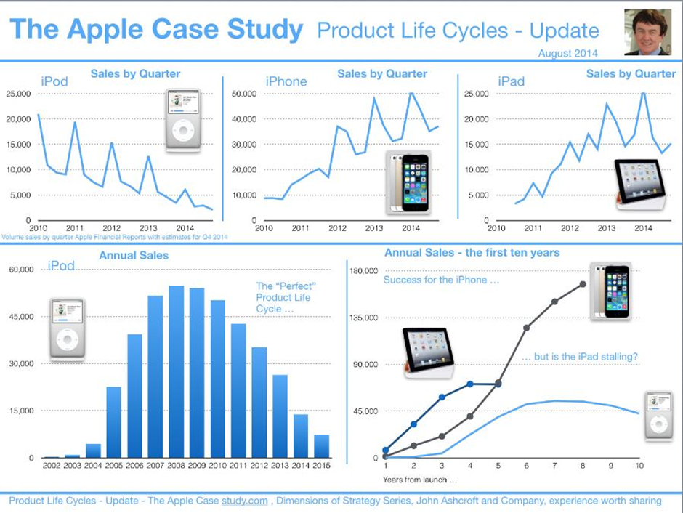

So what is happening to the iPad? Experts attribute this decline primarily to the growing demand for detachable devices. Tablets without a dedicated keyboard are steadily losing relevance in a world where smartphones are now nearly as big. Additionally, key brands in the notebook PC scene, such as HP and Lenovo are also expanding production to include more laptop-tablet hybrids.

But the hybrid doesn’t take all the blame. Trend analysts also suggest that customers are simply not upgrading their aging devices. Mainstream tablet owners often have a smartphone, as well as a PC, all which share the user’s daily workload. Of the three, however, it’s often the tablet that gets used the least. And when it comes to upgrading, the owner will likely buy a new phone and a new laptop first, before coming to the tablet.

Records in 2016 show that Apple is still at the helm of the industry, but the company has not been immune to the overall market difficulties. IPad sales saw a 19 percent decrease in 2016’s fourth quarter, and although the highly-anticipated launch of the iPad Pro was met with acclaim from both reviewers and customers, it did little to salvage the situation.

"As we indicated last quarter, the market is still being impacted by the rise of large-screen smartphones and longer than anticipated ownership cycles," said Jean Philippe Bouchard, IDC Research Director for Tablets. The Phablet (combining phone and tablet) market is emerging as a viable segment, challenging the iPhone and the IPad. So what does this mean for Apple?

Questions:

What stage of the Product Life Cycle is the iPod, iPhone and iPad in? Give reasons to support your answer.

|  |
| --- |
|  |
|  |
|  |
|  |
|  |
|  |
|  |
|  |
|  |
|  |
|  |
|  |
|  |
|  |
|  |

What Marketing strategies would you recommend for the iPad? What would the product life cycle of iPad look like with your proposed recommendation? Please draw it to illustrate.

|  |
| --- |
|  |
|  |
|  |
|  |
|  |
|  |
|  |
|  |
|  |
|  |
|  |

Drawing: